

“Rain Sensor Detection System”
(Arduino Project)
A Project
Presented to the
Information Technology Education Faculty
Legacy College of Compostela, Compostela, Davao de Oro

In partial fulfillment of the Requirements for the degree in Bachelor of Science in Information
Technology

CHAPTER 2

Team Information

Saturnino Cesar Ancog III
Gmail: cesarancog@gmail.com Contact Number: 09510471800 Sherwin C. Labe
Gmail: labesherwin@gmail.com Contact Number: 09451549360

Project Overview

Objective

CHAPTER 3

The objective of this project is to design and implement a rain detection system using an
Arduino board and a rain sensor module. The system will monitor environmental conditions and detect the presence of rain,(such as turning on an LED or activating a relay). This project aims to provide an automated solution for detecting rain in various applications, monitoring weather conditions in outdoor setups.

Descriptions
This rain detection system uses a simple rain sensor module that consists of a conductive
material that detects water. When raindrops fall on the sensor, it changes its resistance, which is read by an Arduino. The Arduino then processes the sensor's input and triggers a re

Key features of the project include:
- Water level Detector: Automatically detects the presence of rain.
- Response Mechanism: Activates an output (like an LED or relay) when rain is detected and servo for outdoor setups.
- Real-Time Monitoring: Continuously monitors environmental conditions and provides real-time feedback serial output

CHAPTER 4
Technical Details

This section provides the technical specifications and details of the components used in the Water Sensor Detection System project. The chapter outlines the key hardware components, their functions, and the power requirements to successfully run the system.

1. Arduino Model
For this project, the Arduino Uno will be used as the main microcontroller. The Arduino Uno is a popular choice due to its ease of use, availability, and wide support community. It provides sufficient input/output pins for handling the sensor data and triggering output devices such as LEDs, relays, or motors.

Model Used: Arduino Uno
Processor: ATmega328P
Operating Voltage: 5V
Digital I/O Pins: 14 (6 can be used as PWM outputs)
Analog Input Pins: 6
Flash Memory: 32 KB
Clock Speed: 16 MHz

2. Components
The following components are essential for the Water Sensor Detection System:

Rain Sensor Module: This sensor detects the presence of water (rain). It has two main parts: a sensing plate (which detects water) and a control module. The plate is made of conductive material, and when water bridges the gaps between the plate’s surface, the resistance changes, signaling the presence of rain.

Operating Voltage: 5V
Output Type: Digital (HIGH or LOW based on the presence of rain)
LED: A simple LED will be used to indicate the system's status. The LED will turn on when the rain sensor detects rain, signaling an alert. It will turn off when the rain stops.

Type: 5mm Red LED (for indication)
Operating Voltage: 2V (for standard LED)
Current: 20mA
Relay Module: A relay module is used to control external devices such as motors or larger equipment, in case the system needs to trigger an action in an outdoor setup, such as chopstick for covering the ground.

Relay Type: 5V relay (single-channel)
Relay Operating Voltage: 5VMaximum Output Voltage: 250V AC / 30V DCServo Motor (Optional): A servo motor can be used in outdoor setups where the system needs to physically interact with an environment, such as adjusting a canopy or opening/closing a water valve.

Operating Voltage: 5V
Torque: 2.5 kg·cm
Rotation: 180°
Resistors: Various resistors are used to limit current in circuits, especially for the LED and sensor inputs. Typically, a 220Ω resistor is used in series with the LED.

Value: 220Ω (for LED)
Tolerance: ±5%
Buzzer (Optional): An additional output device like a buzzer can be used to emit a sound when rain is detected, further enhancing the system’s alert mechanism.

Operating Voltage: 5V
Frequency: 2 kHz
3. Power Supply
The Arduino and its components require a reliable power source to function correctly. This system will be powered through the following means:

Main Power Source: The Arduino Uno can be powered through its USB connection (from a computer or adapter) or using an external 9V DC power supply connected to the power jack on the board.

Input Voltage (Recommended): 7V to 12V DC (through the barrel jack)
Input Voltage (Limits): 6V to 20V DC (via the Vin pin)
Component Powering: Other components such as the sensor module, LED, relay, and servo motor can be powered directly from the 5V output pins of the Arduino board. However, ensure that power demands (e.g., servo motor) do not exceed the Arduino's output capacity.

Powering from Arduino 5V Pin: Suitable for low power devices (e.g., LED, rain sensor)
External Power Source for Servo or Relay: An external 5V power supply or battery can be used to avoid overloading the Arduino board.
Battery Option (for portability): If the system is to be deployed in outdoor locations without direct access to power, a Li-ion rechargeable battery or a 12V battery pack can be used. A battery management module (such as a TP4056 charging module) can also be included to recharge the batteries when needed.

4. Circuit Design and Connections
Rain Sensor to Arduino: Connect the VCC pin of the rain sensor to the 5V pin of the Arduino, the GND pin to the GND of the Arduino, and the output pin (DO) to a digital I/O pin (e.g., D2).

LED to Arduino: The positive lead of the LED will be connected to a digital pin (e.g., D3) through a 220Ω resistor, and the negative lead will go to GND.

Servo to Arduino: The servo motor will be connected to a PWM-enabled pin (e.g., D9) for smooth control of its movement.
CHAPTER 5

Software Requirements

In this chapter, we will outline the software requirements for the Water Sensor Detection System, including the programming tools, languages, and algorithms used to operate the system.

1. Programming Tools
For this project, the primary tool for developing and uploading the code to the Arduino board will be the Arduino Integrated Development Environment (IDE). The Arduino IDE is a user-friendly platform that supports writing, compiling, and uploading code to Arduino microcontrollers.

- Programming Language: The code for the Arduino board will be written in C++ with Arduino-specific libraries and functions. The language used in the Arduino IDE is a simplified version of C++ with specific functions designed to interact with hardware.

- Arduino IDE:

- Version: Latest stable version (1.x or newer)
- Download Link: Arduino IDE
- The IDE supports various platforms (Windows, macOS, Linux) and comes with built-in libraries and tools for compiling and uploading the code to the Arduino board.
- Libraries Used:

- Servo Library: If using a servo motor, the Servo library allows easy control of servo motors.

- Library Name: Servo
- Purpose: Controls the angle of the servo motor.

- Library Name: Standard GPIO pin control (no specific library is required for basic relay control).
- Purpose: Turns on or off external devices based on rain detection.
2. Algorithms and Logic
The key algorithm in the Water Sensor Detection System is focused on continuously monitoring the rain sensor and triggering appropriate responses when rain is detected. Below is a simplified description of the key algorithms:
Main Algorithm:
- Initialize Components:
- Set up the rain sensor as an input device.
- Set up output devices like the LED, relay, and servo as output pins.
- Monitor Rain Sensor:
- Continuously check the rain sensor for a digital HIGH or LOW signal (depending on the rain detection).
- If the rain sensor detects water (i.e., the sensor output goes LOW), the system enters the "Rain Detected" state.

- Rain Detected Logic:
- Turn On LED: When the rain is detected, the LED will be turned on to indicate the presence of rain.
- Activate Relay: If a relay is used, the relay will be triggered, activating an external device (e.g., irrigation system or pump).
- Activate Servo (if applicable): If the system requires a physical response (e.g., adjusting a canopy), the servo motor will be activated to move or adjust an object.
- Optional Buzzer: If desired, a buzzer will sound to give an audible alert for rain detection.

4.Wait for Rain to Stop:
- The system will continuously check the rain sensor until no rain is detected (i.e., the sensor returns a HIGH signal).
- If no rain is detected, the system will enter the "Rain Not Detected" state.

5.Rain Not Detected Logic:
- Turn Off LED: When no rain is detected, the LED will turn off.
- Deactivate Relay: The relay is deactivated, turning off any external devices previously activated.
- Stop Servo Movement: If the servo motor was activated, it will return to its default position or remain idle.

6. Real-Time Monitoring:

- The system continuously monitors the sensor data in real-time and reacts accordingly.
- Data can be optionally displayed on an LCD screen if used.
CHAPTER 6

System Design

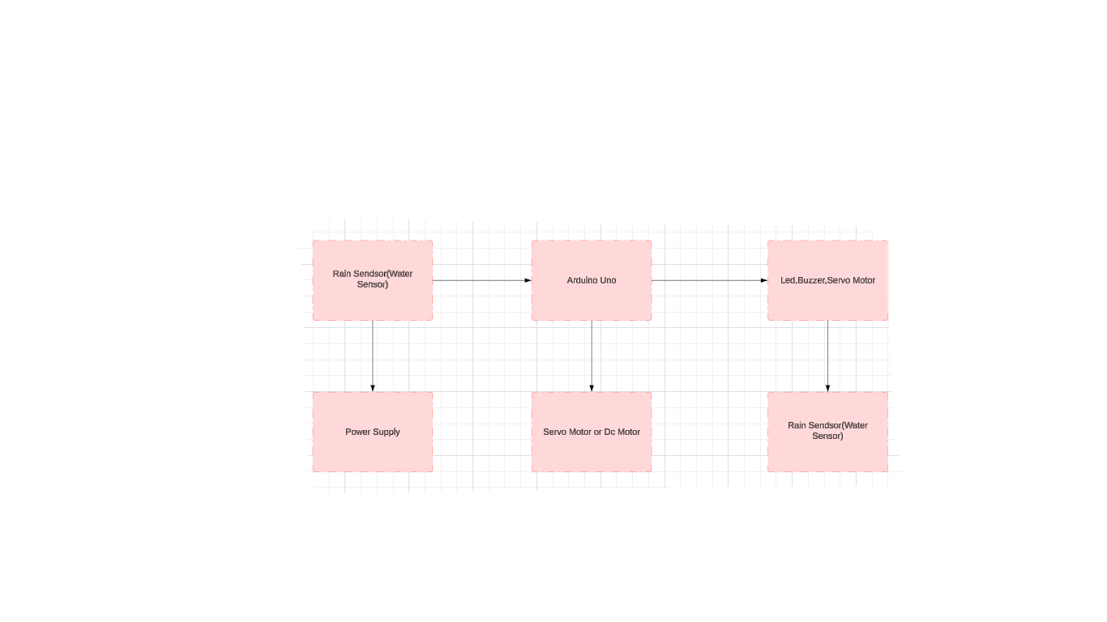
In this chapter, we will outline the System Design for the Water Sensor Detection System. This includes a Block Diagram to show how the components are connected and a Flowchart to demonstrate the logic of the program.

1. Block Diagram
The Block Diagram below illustrates the connections between the various components of the Water Sensor Detection System:

Rain Sensor: The rain sensor detects the presence of rain by monitoring water levels. It sends a signal to the Arduino (either HIGH or LOW) based on rain detection.
- Arduino Board: The heart of the system, processing the rain sensor input and controlling the outputs. The Arduino receives input from the rain sensor and sends signals to the LED, relay, or servo.
- Output Devices:
- LED: The LED lights up when rain is detected, serving as a visual alert.
- Relay: The relay can activate external devices, like a pump or irrigation system.
- Servo Motor: If applicable, the servo motor adjusts outdoor devices (e.g., canopy or valve) based on the rain detection.
- Power Supply: Powers the Arduino and connected components. It can be supplied via USB or an external 9V DC source.
- The diagram shows how the sensor feeds input to the Arduino, which then controls the output devices based on the detection of rain.

2. Flowchart
The Flowchart below outlines the logic and decision-making process of the system program:
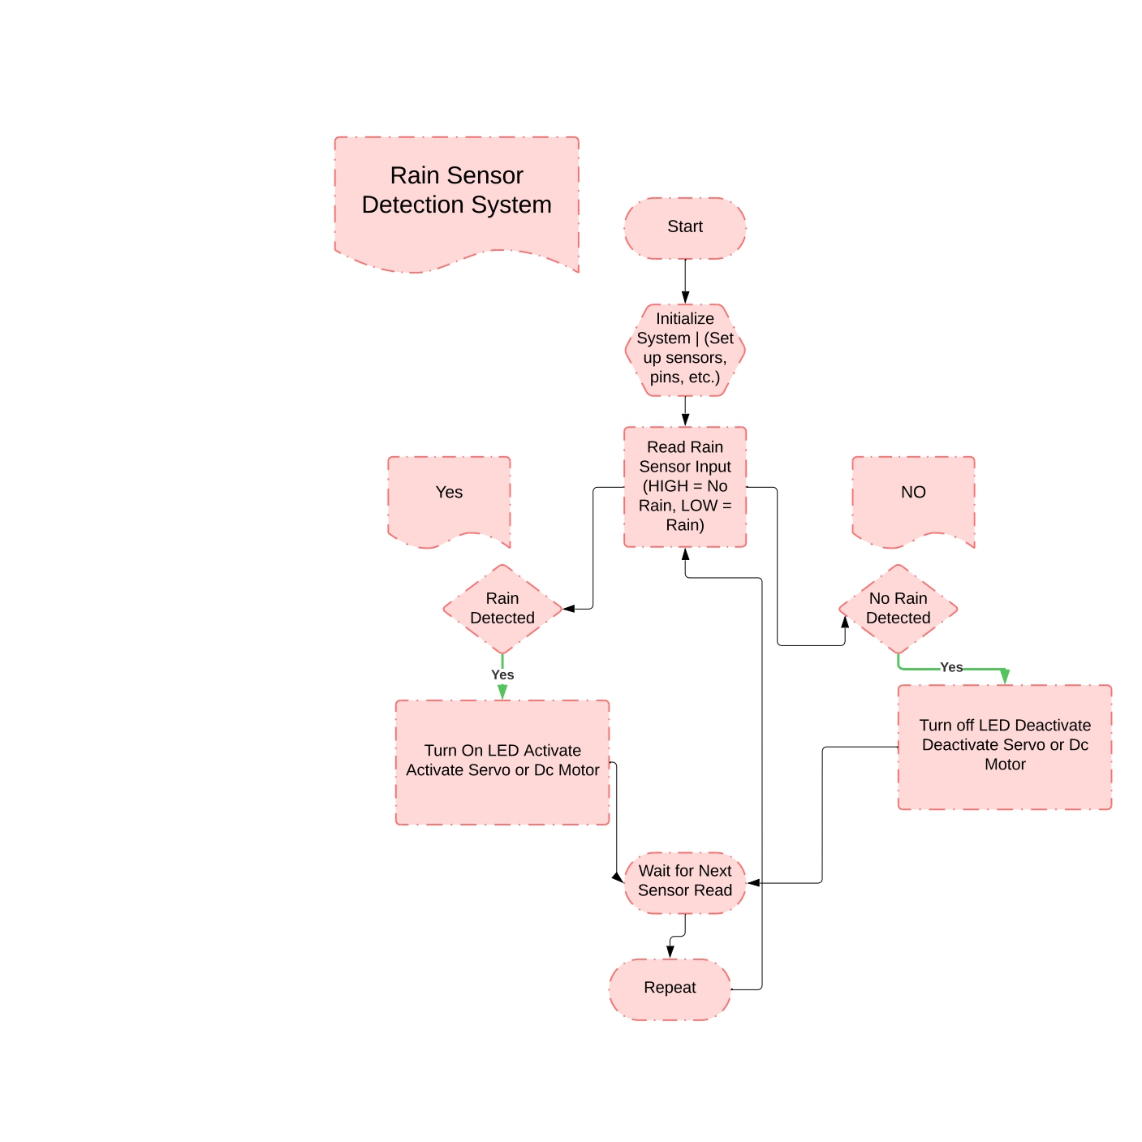

Start: The system starts by initializing the components such as the rain sensor, LEDs, relays, and servo motors.
- Read Rain Sensor Input: The Arduino continuously reads the digital input from the rain sensor.
- Rain Detected: If the sensor detects water (i.e., input is LOW), the system:
- Turns on the LED.
- Activates the relay to control external devices (e.g., pump, irrigation system).
- Moves the servo motor (if applicable).
- No Rain Detected: If no rain is detected (i.e., input is HIGH), the system:
- Turns off the LED.
- Deactivates the relay.
- Resets or stops the servo motor.
- Wait for Next Read: The system waits for the next input reading from the rain sensor and repeats the process.

CHAPTER 7

Expected Outcomes

1. Project Functionality and Expected Outcomes
The Water Sensor Detection System is designed to automatically detect the presence of rain and trigger various actions based on the sensor's input. The system is intended to operate autonomously, with minimal user intervention. Here’s what the system will do:
- Rain Detection: The rain sensor continuously monitors the environment for water (rain). When raindrops fall on the sensor, the resistance of the sensor changes, allowing the Arduino to detect the presence of rain.
- Trigger Alerts: Upon detecting rain, the system will trigger one or more outputs:
  - LED Indicator: The LED will light up as a visual indicator of rain detection.
  - Servo Control: If applicable, a servo motor can be activated to adjust outdoor setups (e.g., opening or closing a canopy or valve).
  - Audible Alert (Optional): An optional buzzer could sound to provide an audible notification when rain is detected.
- Automatic Response: The system operates autonomously, continuously monitoring for rain and activating/deactivating the outputs as necessary. It will automatically turn off the LED, deactivate the relay, and stop the servo when rain is no longer detected.
- Real-Time Monitoring: The system will provide real-time feedback, continuously reading from the rain sensor and responding instantly to changes in environmental conditions.
Expected End Result:
- The project will successfully automate rain detection and response for various applications, such as irrigation systems, weather monitoring, or outdoor setups like canopies or covers.
- The system will provide a reliable and efficient way to monitor and respond to weather conditions, reducing manual effort and enhancing automation in outdoor environments.

CHAPTER 8

Project Timeline

The project will be broken down into several key tasks, each with an estimated timeline:
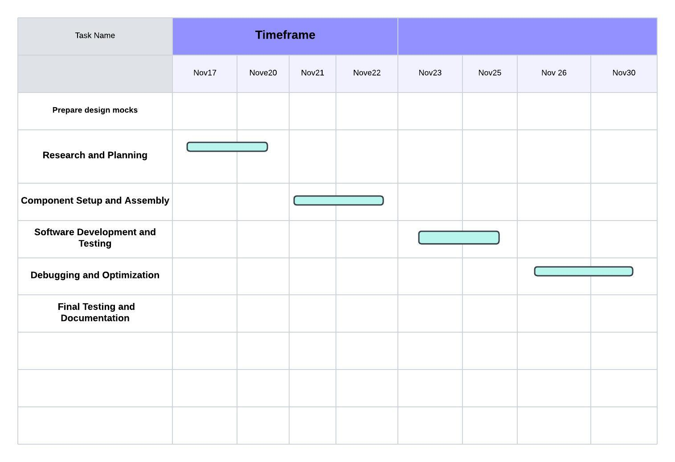

CHAPTER 9

Challenges and Risks

The project may face several challenges and risks, including:

- Sensor Accuracy: The rain sensor may not be highly accurate, leading to false readings.

- Solution: Calibrate the sensor and adjust its threshold sensitivity.
- Power Supply Issues: The system may face power-related problems, especially if external devices (e.g., pumps) are connected.

- Solution: Use a stable power source and consider using a separate power supply for high-power components.
- Software Bugs: Errors in the code may affect system functionality.

- Solution: Regularly test the system, use debugging tools, and carefully review code.
- Hardware Compatibility: Some components may not work well together.

- Solution: Ensure all components are compatible before starting assembly, and perform compatibility tests.

CHAPTER 10

References

1. Arduino Documentation:

- Official Arduino website: https://www.arduino.cc
- This resource provided detailed documentation on Arduino programming, pin configurations, and libraries.

2.Servo Motor , Dc Motor and Buzzer Documentation:

- Documentation and examples for controlling servos and relays using Arduino, available on websites like Arduino Project Hub.

3.Online Tutorials and Forums:

- Tutorials from websites like Instructables and Stack Overflow for solving common issues related to Arduino coding, wiring, and troubleshooting.

4.Books on Arduino Projects:

- "Arduino Projects Book" by Scott Fitzgerald (for examples of Arduino-based automation systems).
- "Getting Started with Arduino" by Massimo Banzi (for foundational knowledge on Arduino programming and hardware).
- These sources were essential for researching, designing, and building the system, as well as for troubleshooting and optimizing its components.

